**National School of Business Management**

**SAMPLE PAPER**

**Year 1 Semester 2**

**Programming in Java**

**BMIS108**

**Time: 03Hrs**

**Answer All Questions Date:**

1. Fill in the blanks. Please transfer your answers to booklet. (12 marks)
2. Real-world objects contain ___ and ___.
3. A software object's state is stored in ___.
4. A software object's behavior is exposed through ___.
5. Hiding internal data from the outside world, and accessing it only through publicly exposed methods is known as data ___.
6. A blueprint for a software object is called a ___.
7. Common behavior can be defined in a ___ and inherited into a ___ using the ___ keyword.
8. A collection of methods with no implementation is called an ___.
9. A namespace that organizes classes and interfaces by functionality is called a ___.
10. The term API stands for ___
11. Consider the following code snippet.

import java.util.Collection;

import java.util.HashSet;

public class StaticBindingTest {

public static void main(String args[]){

Collection c = new HashSet();

StaticBindingTest et = new StaticBindingTest();

et.sort(c);

}

public Collection sort(Collection c){

System.*out.println("Inside Collection sort method");*

return c;

}

public Collection sort(HashSet hs){

System.*out.println("Inside HashSet sort method");*

return hs;}}

1. Identify OOP concept applied inside the program. (2 mark)
2. Derive the output of the program. (2 mark)
3. Briefly explain the rationale behind your answer. (3 mark)
4. Briefly explain the ‘Encapsulation’ concept using a simple code block. This class could contain one integer variable, one double variable and a String variable. (5 mark)
5. Refer the below diagram and derive required classes/interfaces with methods. (6 mark)

<<interface>>Speaker

speak()

Lecturer

speak()

Speaker

Musician

speak()

Speaker

Politician

speak()

Speaker

1. **JDBC** is used for accessing databases from Java applications. Information is transferred from relations to objects and vice-versa.

Write code snippet to querying with preparedStatement which will delete an employee called “Bogdan” holding employee id “E10875” from table “Employee”. For this you’re asked to connect to a DB called “EMPDB” which is hosted using Local host. (15 Mark)

* 1. What is an “Exception”? List down main types of exceptions. (5 mark)
  2. Briefly explain the possible exception handling mechanisms available in java. Please provide required code snippets. (5 mark)
  3. Declare your own exception class which includes two variables to store account number and balance. Derive methods to deposit money and withdraw, this will throws an exception InsufficientFundsException if there’s no sufficient balance. (10 marks)

1. Java Swing describes developing graphical user interfaces (GUIs) for applications and applets using Swing components.

Develop you own code for the below scenario: When you click on the button background will change into the selected color. (15 marks)

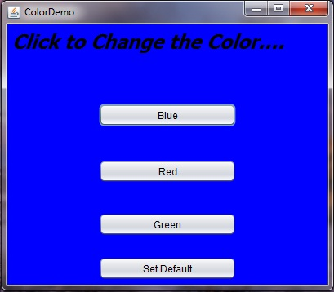

1. What is a thread? (3 mark)
2. What is difference between wait() and sleep() method? (2 mark)
3. What is a ‘daemon thread’? Give at least one example. (3 mark)
4. Write a program which will create a named Threads called (“ThreadRunner”). Retrieve the thread priority and if the thread priority is below 6 set the thread priority to 6. Then run the thread to print thread name 10 times on the console. (12 Mark)